Program:

#include <stdio.h>

#include <math.h>

int a = 0,b = 0, c = 0, a1 = 0, b1 = 0, com[5] = { 1, 0, 0, 0, 0};

int anum[5] = {0}, anumcp[5] = {0}, bnum[5] = {0};

int acomp[5] = {0}, bcomp[5] = {0}, pro[5] = {0}, res[5] = {0};

void binary(){

a1 = fabs(a);

b1 = fabs(b);

int r, r2, i, temp;

for (i = 0; i < 5; i++){

r = a1 % 2;

a1 = a1 / 2;

r2 = b1 % 2;

b1 = b1 / 2;

anum[i] = r;

anumcp[i] = r;

bnum[i] = r2;

if(r2 == 0){

bcomp[i] = 1;

}

if(r == 0){

acomp[i] =1;

}

}

c = 0;

for ( i = 0; i < 5; i++){

res[i] = com[i]+ bcomp[i] + c;

if(res[i] >= 2){

c = 1;

}

else

c = 0;

res[i] = res[i] % 2;

}

for (i = 4; i >= 0; i--){

bcomp[i] = res[i];

}

if (a < 0){

c = 0;

for (i = 4; i >= 0; i--){

res[i] = 0;

}

for ( i = 0; i < 5; i++){

res[i] = com[i] + acomp[i] + c;

if (res[i] >= 2){

c = 1;

}

else

c = 0;

res[i] = res[i]%2;

}

for (i = 4; i >= 0; i--){

anum[i] = res[i];

anumcp[i] = res[i];

}

}

if(b < 0){

for (i = 0; i < 5; i++){

temp = bnum[i];

bnum[i] = bcomp[i];

bcomp[i] = temp;

}

}

}

void add(int num[]){

int i;

c = 0;

for ( i = 0; i < 5; i++){

res[i] = pro[i] + num[i] + c;

if (res[i] >= 2){

c = 1;

}

else{

c = 0;

}

res[i] = res[i]%2;

}

for (i = 4; i >= 0; i--){

pro[i] = res[i];

printf("%d",pro[i]);

}

printf(":");

for (i = 4; i >= 0; i--){

printf("%d", anumcp[i]);

}

}

void arshift(){

int temp = pro[4], temp2 = pro[0], i;

for (i = 1; i < 5 ; i++){

pro[i-1] = pro[i];

}

pro[4] = temp;

for (i = 1; i < 5 ; i++){

anumcp[i-1] = anumcp[i];

}

anumcp[4] = temp2;

printf("\nAR-SHIFT: ");

for (i = 4; i >= 0; i--){

printf("%d",pro[i]);

}

printf(":");

for(i = 4; i >= 0; i--){

printf("%d", anumcp[i]);

}

}

void main(){

int i, q = 0;

printf("\t\tBOOTH'S MULTIPLICATION ALGORITHM");

printf("\nEnter two numbers to multiply: ");

printf("\nBoth must be less than 16");

do{

printf("\nEnter A: ");

scanf("%d",&a);

printf("Enter B: ");

scanf("%d", &b);

}while(a >=16 || b >=16);

printf("\nExpected product = %d", a \* b);

binary();

printf("\n\nBinary Equivalents are: ");

printf("\nA = ");

for (i = 4; i >= 0; i--){

printf("%d", anum[i]);

}

printf("\nB = ");

for (i = 4; i >= 0; i--){

printf("%d", bnum[i]);

}

printf("\nB'+ 1 = ");

for (i = 4; i >= 0; i--){

printf("%d", bcomp[i]);

}

printf("\n\n");

for (i = 0;i < 5; i++){

if (anum[i] == q){

printf("\n-->");

arshift();

q = anum[i];

}

else if(anum[i] == 1 && q == 0){

printf("\n-->");

printf("\nSUB B: ");

add(bcomp);

arshift();

q = anum[i];

}

else{

printf("\n-->");

printf("\nADD B: ");

add(bnum);

arshift();

q = anum[i];

}

}

printf("\nProduct is = ");

for (i = 4; i >= 0; i--){

printf("%d", pro[i]);

}

for (i = 4; i >= 0; i--){

printf("%d", anumcp[i]);

}

}

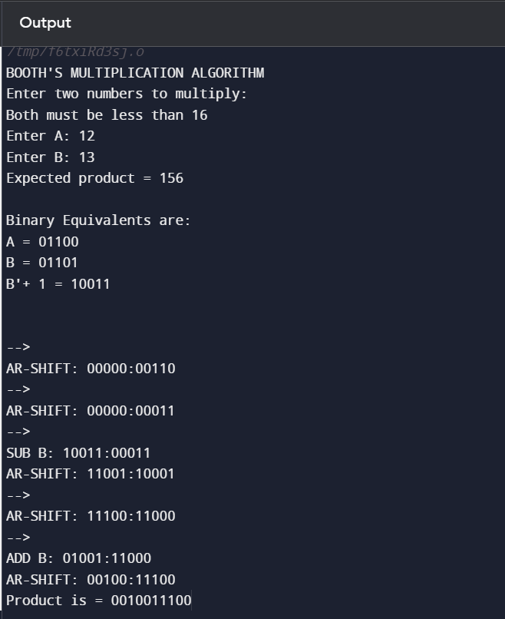Output: